Packet Tracer - Investigate STP Loop Prevention ( THY DAYUTH )

Objectives
In this lab, you will observe spanning-tree port states and watch the spanning-tree convergence process.
- Describe the operation of Spanning Tree Protocol.
- Explain how Spanning Tree Protocol prevents switching loops while allowing redundancy in switched networks.

Background / Scenario
In this activity you will use Packet Tracer to observe the operation of Spanning Tree Protocol in a simple switched network that has redundant paths.

Instructions

Observe a Converged Spanning-Tree Instance

Verify Connectivity.
Ping from PC1 to PC2 to verify connectivity between the hosts. Your ping should be successful.

View spanning-tree status on each switch.
Use the show spanning-tree vlan 1 command to gather information about the spanning tree status of each switch. Complete the table. For the purposes of the activity, only consider information about the Gigabit trunk ports. The Fast Ethernet ports are access ports that have end devices connected and are not part of the inter-switch trunk-based spanning tree.
Open configuration window
Switch | Port | Status (FWD, BLK…) | Root Bridge?
S1 | G0/1 | FWD | No
S1 | G0/2 | FWD | No
S2 | G0/1 | FWD | Yes
S2 | G0/2 | FWD | Yes
S3 | G0/1 | FWD | No
S3 | G0/2 | BLK | No
Blank Line - no additional information
Packet Tracer uses a different link light on one of the connections between the switches.

Questions:
What do you think this this link light means?
It indicating that the path is blocked
What path will frames take from PC1 to PC2?
Pc1 – S1 – S2 – S3 – S2 - Pc2
Why do the frames not travel through S3?
Because G0/2 is blocked
Why has spanning tree placed a port in blocking state?
It blocks port to prevent layer 2 loops
Close configuration window

Observe spanning-tree convergence

Remove the connection between S1 and S2.
      - Open a CLI window on switch S3 and issue the command show spanning-tree vlan 1. Leave the CLI window open.
Open configuration window
      - Select the delete tool from the menu bar and click the cable that connects S1 and S2.

Observe spanning-tree convergence.
      - Quickly return to the CLI prompt on switch S3 and issue the show spanning-tree vlan 1 command.
      - Use the up-arrow key to recall the show spanning-tree vlan 1 command and issue it repeatedly until the orange link light on the cable turns green. Observe the status of port G0/2.

Question:
What do you see happen to the status of the G0/2 port during this process?
Initially the port was blocked but after the deletion of S1-S2 route, the port moved to learning state (LRN). While instantly, it’s not sending data to the user but rather build MAC address table for traffic and finally the port moved to FWD ( forwarding ) both turning green
You have observed the transition in port status that occurs as a spanning-tree port moves from blocking to forwarding state.
      - Verify Connectivity by pinging from PC1 to PC2. Your ping should be successful.

Question:
Are any ports showing an orange link light that indicates that the port is in a spanning-tree state other than forwarding? Explain.
By deleting the physical line between S1 and S2, it no longer operate in a circle loop which no need for the STP to block any port. Therefor, STP put every port into FWD to ensure the data can travel from PC1 - PC2
Close configuration window
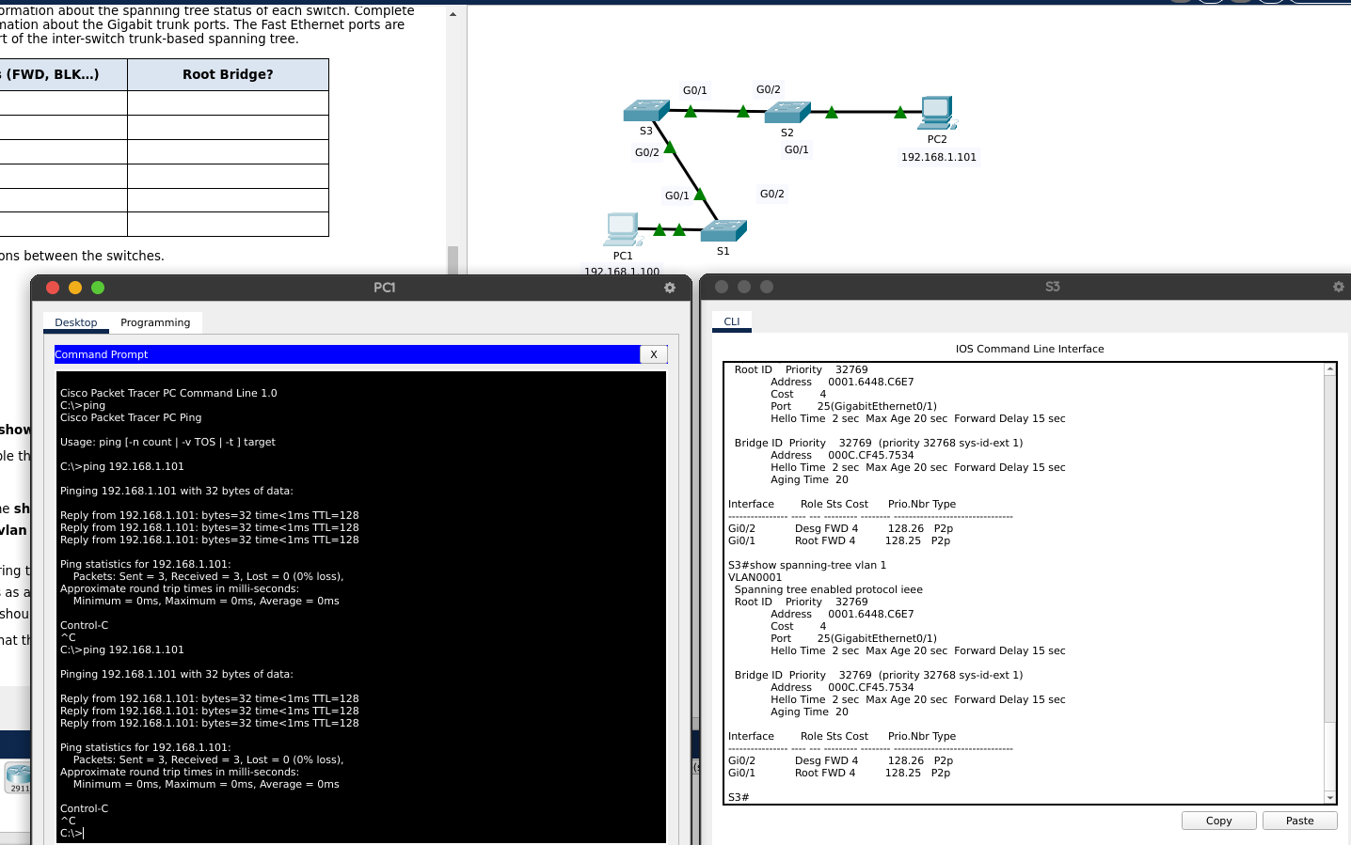
End of document

